Virtual MLK Media Campaign Report
Compiled by Rebecca Cross, Candice Edrington, and Melody Hunter-Pillion

Table of Contents

Introduction 3

Purpose of Report 3

Timeline 4

Summary of Tasks 6

Executive Summary of Results 6

Evaluation 8

Future Recommendations 8

Appendices 10
Appendix A: Media Advisory
Appendix B: Invitation
Appendix C: Postcard
Appendix D: Letter to Local Churches
Appendix E: Press Release
Appendix F: Individual Media Pitch to WRAL

Introduction

The Communication Plan for the vMLK Project 2020 had three main goals: 1) to invite and engage the local community to attend the 60th Anniversary of the “Fill up the Jails” speech, hosted at the James B. Hunt Jr. Library 2) to inform the general public about the enhanced virtual reality platform and about related activities for children and K-12 students, and 3) to create an ongoing conversation about advocacy with an expanded audience.

Drafting the Communication Plan and delivering/implementing the communication tactics was a collaborative effort. Dr. Victoria J. Gallagher gathered a team of university communicators, PhD students, master’s students, and undergraduate students to inform communication strategy, branding, media relations, and written communications. Drafting the Communication Plan for the 60th anniversary of the “Fill up the Jails” speech began in the fall of 2019. Work on the plan concluded with the Feb. 15, 2020, 60th Anniversary of a Creative Protest Exhibition. The resounding positive feedback and high attendance from members of the media, NC State community, and at-large community illustrate the success of the Communication Plan and its implementation.

Purpose of Report

The vMLK Project touches a variety of spheres since it has historical, community, and academic significance. As an iterative and multi-faceted project, it is important to keep records of how project leaders are stewarding their resources and ensuring the project’s contributions to stakeholders. While the contributions to stakeholders are far-reaching, this report seeks to specifically detail the communication efforts beginning in the Fall of 2019 and leading up to the Feb. 15, 2020, 60th Anniversary of a Creative Protest Exhibition. This report will document the process for creating the communication plan, detail the facets of the plan, and provide links and summaries of key coverage of the event.

Timeline

 | Strategy | Implementation | Dates
Media Objectives:
First Team Meeting | Meet to discuss upcoming event |  | October 15, 2019
Create Media Lists | General Media List and AA Media List | Received lists from NCDNCR Communications | November 19, 2019
Design Students Present Branding Ideas | Vote on best branding ideas created by design students |  | December 6, 2019
Create Media Advisory | Media Advisory should highlight event, what’s new and useful about project, community focus  Distribute to Triangle media outlets | Final Draft/Distribution | December 6-13  Distributed  December 16
Create postcard inserts/invites | 2 handouts - consistent branding  - Geared toward families with children  - Geared to church congregations and general public | - Final Draft/Distribution to Wake and Durham Co. Libraries  - Final Draft/Distribution to Wake and Durham churches and colleges/universities | January 14, 2020
NCSU Web Blasts / Social Media | Create event message with images to target NCSU main home page, CHASS home page, NCSU Libraries home page, Communication homepage, Twitter, Facebook, Instagram | Final text, images and link to share  Using elements from postcard invite for social media and web. | January 14, 2020
WUNC-Radio Pitch | Customized pitch to Frank Stasio and producer Laura Pellicer | ID interviewees and compelling sound to share, plus image for WUNC website | Jan. 19, 2020 - Emailed pitch to WUNC Radio’s Laura Pellcier (Frank Stasio’s State of Things producer)
UNC-TV Pitch | Customized pitch to Deborah Holt-Noel | ID interviewees and b-roll/ topic pitch | Jan. 22, 2020
Possible Media Day | Provide media with advance, exclusive look of the virtual experience | Checking with project and library | February 14, 2020
Create News Release | News Release  (provide logistics, background info, and web link to vMLK project) | Final Draft/Distribution | Week of Feb. 15, 2020
Day of Event | Engage with media onsite during event |  | February 15, 2020

Summary of Tasks

The team selected to assist with the media efforts for the vMLK 60th anniversary of A Creative Protest exhibition possessed many different talents. Given this wide array of expertise, team members were designated to lead specific tasks. With a background in journalism and media, Melody Hunter-Pillion led the efforts in contacting local media outlets and coordinating interviews. Chris Tonelli, Director of External Relations for NC State University Libraries, assisted to ensure all materials were on brand with university communication guidelines. Candice Edrington assisted with crafting the messages for all marketing material, including invitations, postcards, and letters to local churches, because of her professional experience in public relations. With connections to the community, Rebecca Cross assisted with compiling lists of local media outlets, colleges/universities, and relevant organizations. On the day of the event, February 15, 2020, these individuals continued their efforts by volunteering to guide visitors through the exhibit.

Executive Summary of Results

The campaign’s strategy to target individual television and radio stations with specific story pitches, combined with sharing general media advisories and news releases with all news outlets, worked to great advantage. It increased the probability of guaranteed coverage to offer a story, complete with interviewees, b-roll, and pre-event onsite accessibility. In particular, the team used direct email contact with WRAL-TV5 Anchor/Report Mikaya Thurmond, who in turn booked a live studio Sunday morning newscast interview with Dr. Victoria Gallagher and Dr. Derek Ham two weeks before the event. That story was repeated again during the station’s evening broadcasts at 6 p.m. and 11 p.m. Thurmond visited Hunt Library six days before the event for another pre-event story and promotion, interviewing doctoral candidates Candice Edrington and Max Renner. Running this story a day before the event as a reminder likely assisted our efforts in drawing what turned out to be a large, enthusiastic, and diverse crowd in age, race, and ethnicity (total attendance at the event is estimated, based on entrance counts into the Hunt library at 500). The advantage of intense coverage by WRAL is demonstrated by the fact that most of their stories are archived on their websites, one of the most trafficked local sites in the nation. They also garner a large share of the local broadcast market audience, and their packaged stories are well produced.

Coverage on the day of the event included three of the local news stations, including WRAL-TV5, WTVD-ABC11, and Spectrum 14 Carolina. Included below is a summary of the story appearances that can be found via Google search, local station website searches, and from notations on event day. More accurate recordings of exact story counts, hits and audience could be captured through a for pay service for analytics like Metro Monitor or other sources.

Spectrum News – January 19, 2020
“Virtual MLK Project Stops in Cary”
Full package by reporter Evan Sery. Ran evening of Jan. 19 and morning of Jan. 20
Interview Dr. Derek Ham and Dr. Victoria Gallagher at Christ the King Church
https://spectrumlocalnews.com/nc/charlotte/news/2020/01/19/virtual-mlk-project

WRAL-TV – Feb. 2, 2020 at 7:40 a.m. Sunday morning newscast
Live interview on set with Mikaya Thurmond interviewing Dr. Gallagher and Dr. Ham
No on line capture of this 3:00 (3-minute) interview. (Set and collect recordings).

WRAL-TV5 – Feb. 9 and Feb. 10, 2020
Full package by Anchor Mikaya Thurmond, with a standup at Hunt Library. Package promoted
the event. Interviewees were Candice Edrington and Max Renner
https://www.wral.com/virtual-reality-brings-dr-king-s-famous-durham-speech-to-nc-state/18942208/
Package ran evening of Feb. 9, morning of Feb. 10, VO (voiceover video) on Feb. 14

WUNC Radio – Feb. 14, 2020
State of Things host Frank Stasio conducted live interview with Dr. Gallagher and Dr. Ham
Available online
https://www.wunc.org/post/virtual-mlk-project-uses-technology-recover-history

BPR (Blue Ridge Public Radio) – Feb. 14, 2020
Ran Frank Stasio’s State of Things interview with Dr. Gallagher and Dr. Ham
Available online
https://www.bpr.org/post/virtual-mlk-project-uses-technology-recover-history#stream/0

Feb. 15 Coverage - No online stories found; however, crews shot and ran stories
WRAL
WTVD-ABC11
Spectrum News14
Evaluation

The goals of the vMLK media campaign plan were to 1) to invite and engage the local community to attend the 60th Anniversary of the “Fill up the Jails” speech, hosted at the James B. Hunt Jr. Library 2) to inform the general public about the enhanced virtual reality platform and about related activities for children and K-12 students, and 3) to create an ongoing conversation about advocacy with an expanded audience. In assessing the efforts of this campaign, two key strengths were identified; collaboration and personalization.

- Collaboration. The execution of the communication plan involved faculty, leading university communicators, library personnel, and undergraduate and graduate students. Involving individuals from varied backgrounds allowed the message to be communicated broadly and effectively.

- Personalization. Including personalized, individual pitches to local members of the media was an effective appeal for coverage. Efforts to reach media outlets that shared a vested interest in this particular story proved advantageous to this campaign as the project received increased, focused coverage due to these personalized pitches. In particular, the WRAL news coverage featuring Candice Edrington and Max Renner was shared on Facebook 280 times. An example of these personalized pitches can be found in Appendix F.

Future Recommendations

Given the overall response to the 60th Anniversary of the “Fill up the Jails” speech, hosted at the James B. Hunt Jr. Library, the media campaign proved to be successful. After a thorough evaluation, there are several recommendations for future events, including media coverage, digital marketing, and brand consistency.

- Media Coverage. While media coverage was superb for the event, recalling archived reports for the project’s records proved to be difficult. In the future, project leaders should immediately follow-up with reporters for coverage data. This could include but is not limited to copies of publicized news segments and audience engagement metrics.

- Digital Marketing. Creating strategic messages on already established project social media pages could help reach a wider audience. Posting key messages frequently in addition to engaging with page friends/followers could help foster great community relations among the project and the surrounding communities.

- Brand Consistency. The creation and implementation of a vMLK branding style guide could aid in maintaining brand consistency. Adhering to consistent branding could assist in the recognition of messages and increased awareness throughout the immediate community.

Appendix A: Media Advisory
Media Advisory
NC State Virtual MLK Project to Commemorate 1960 Speech

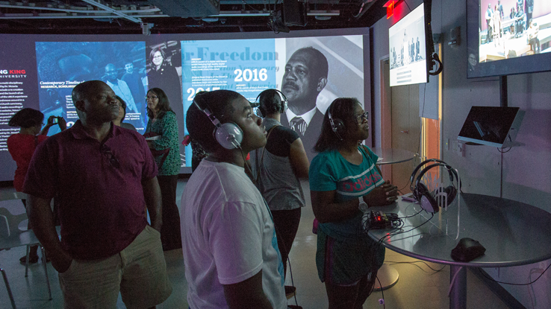
Raleigh, N.C. - On February 15, 2020, NC State researchers, led by Dr. Victoria Gallgher, will immerse community members in one of Martin Luther King Jr.’s most iconic speeches. King delivered this speech, originally titled “A Creative Protest” but later referred to by King and others as “Fill Up the Jails,” on February 16, 1960 at White Rock Baptist Church in Durham. The Virtual MLK (vMLK) event will take audiences back in time by leveraging the James B. Hunt Jr. Library’s 270-degree visualization capabilities, allowing them to virtually walk around the historic sanctuary, hear a re-creation of King’s speech, and virtually sit with congregation members. Events at the Hunt Library will include a choral performance, family activities, guided tours, and a community discussion on advocacy.
Just as members of local churches, college students, and community leaders attended the 1960 event, the 2020 vMLK event invites the community to join these activities, tours, and discussions. Participants can experience the speech as an audience member, reflect on King’s words, and celebrate his legacy. The vMLK project will soon be available to K-12 classrooms, helping students understand Civil Rights history and current-day advocacy.

Event Details:
February 15, 2020
10 a.m. – 3 p.m.
James B. Hunt Jr. Library
N.C. State University Centennial Campus
1070 Partners Way
Raleigh, NC 27606
For interviews and additional information, please contact Chris Tonelli, Director of External Relations for the NC State University Libraries, at 919-515-2595 or catonell@ncsu.edu.

Appendix B: Invitation

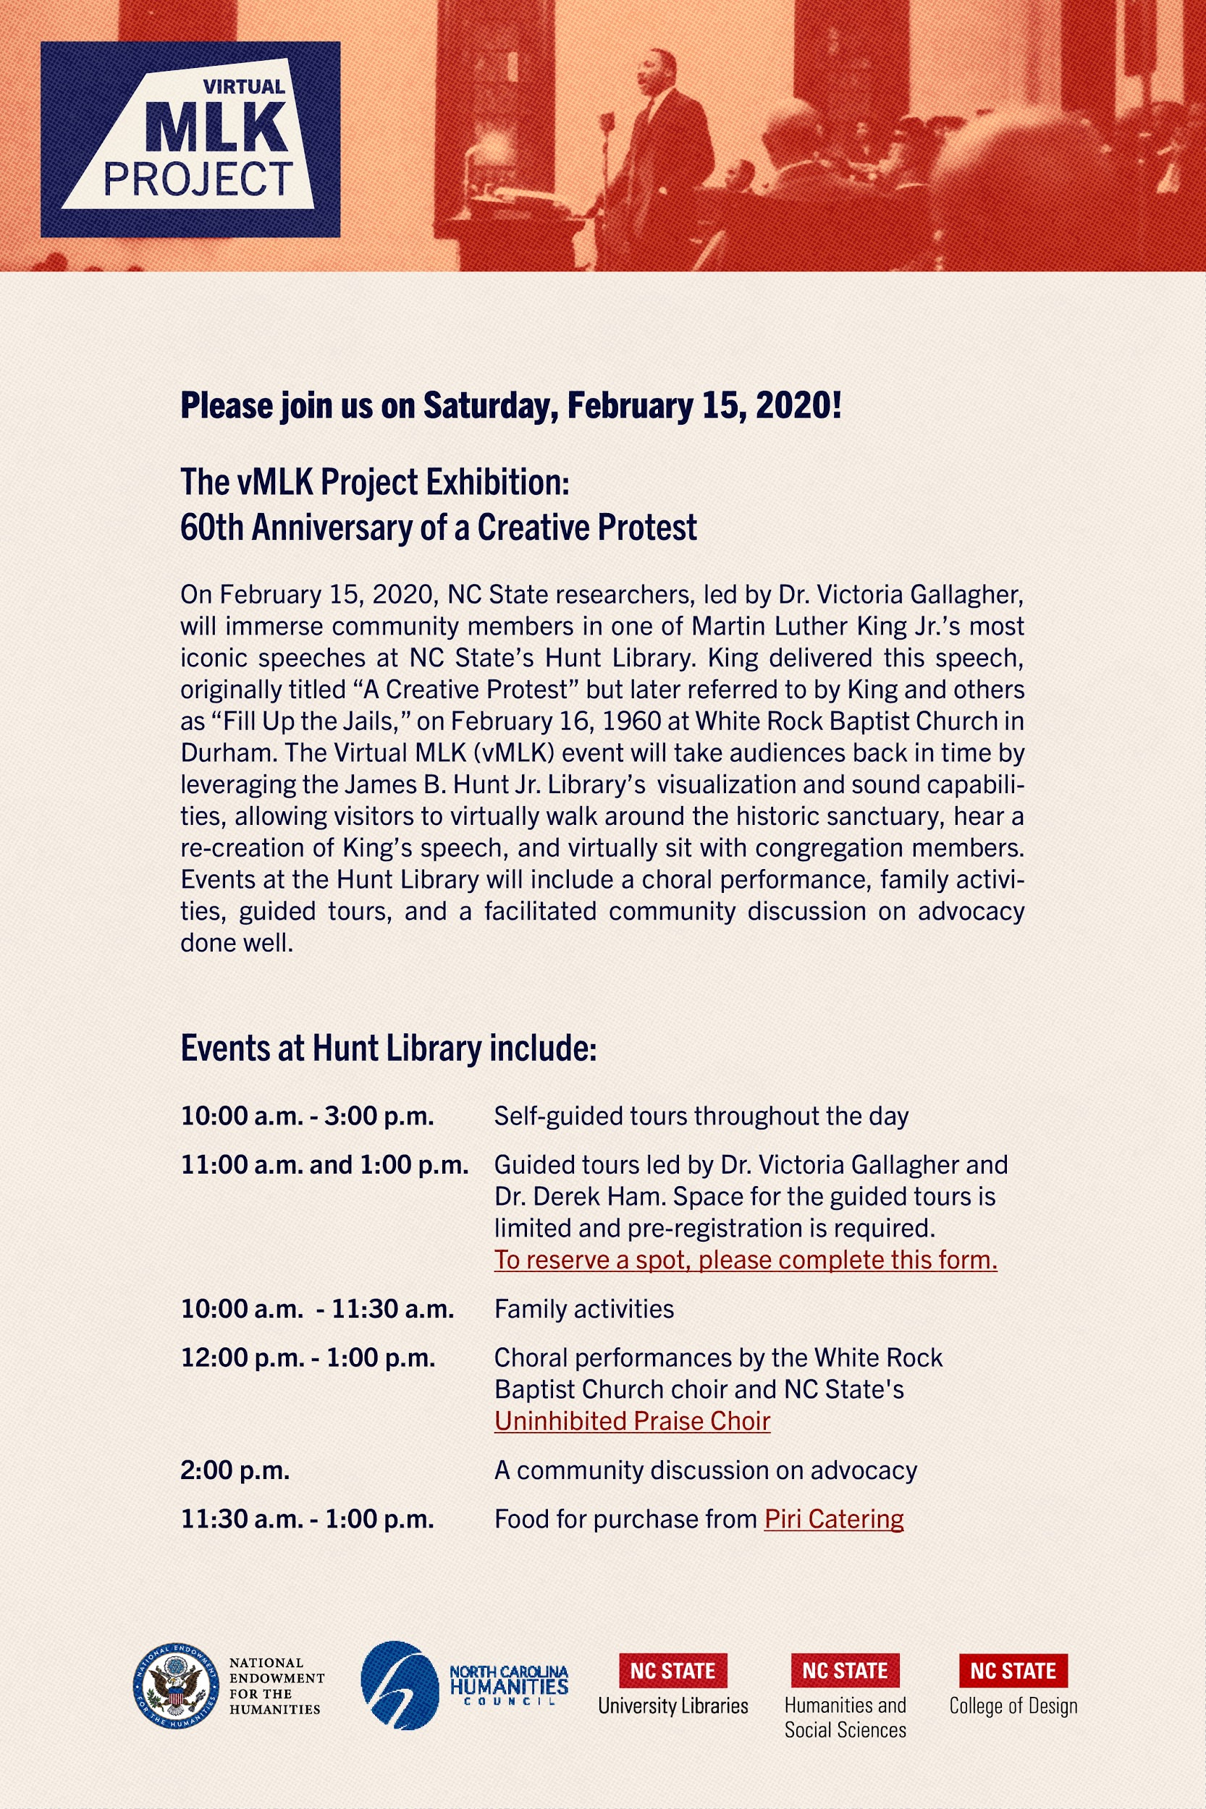

Appendix C: Postcard

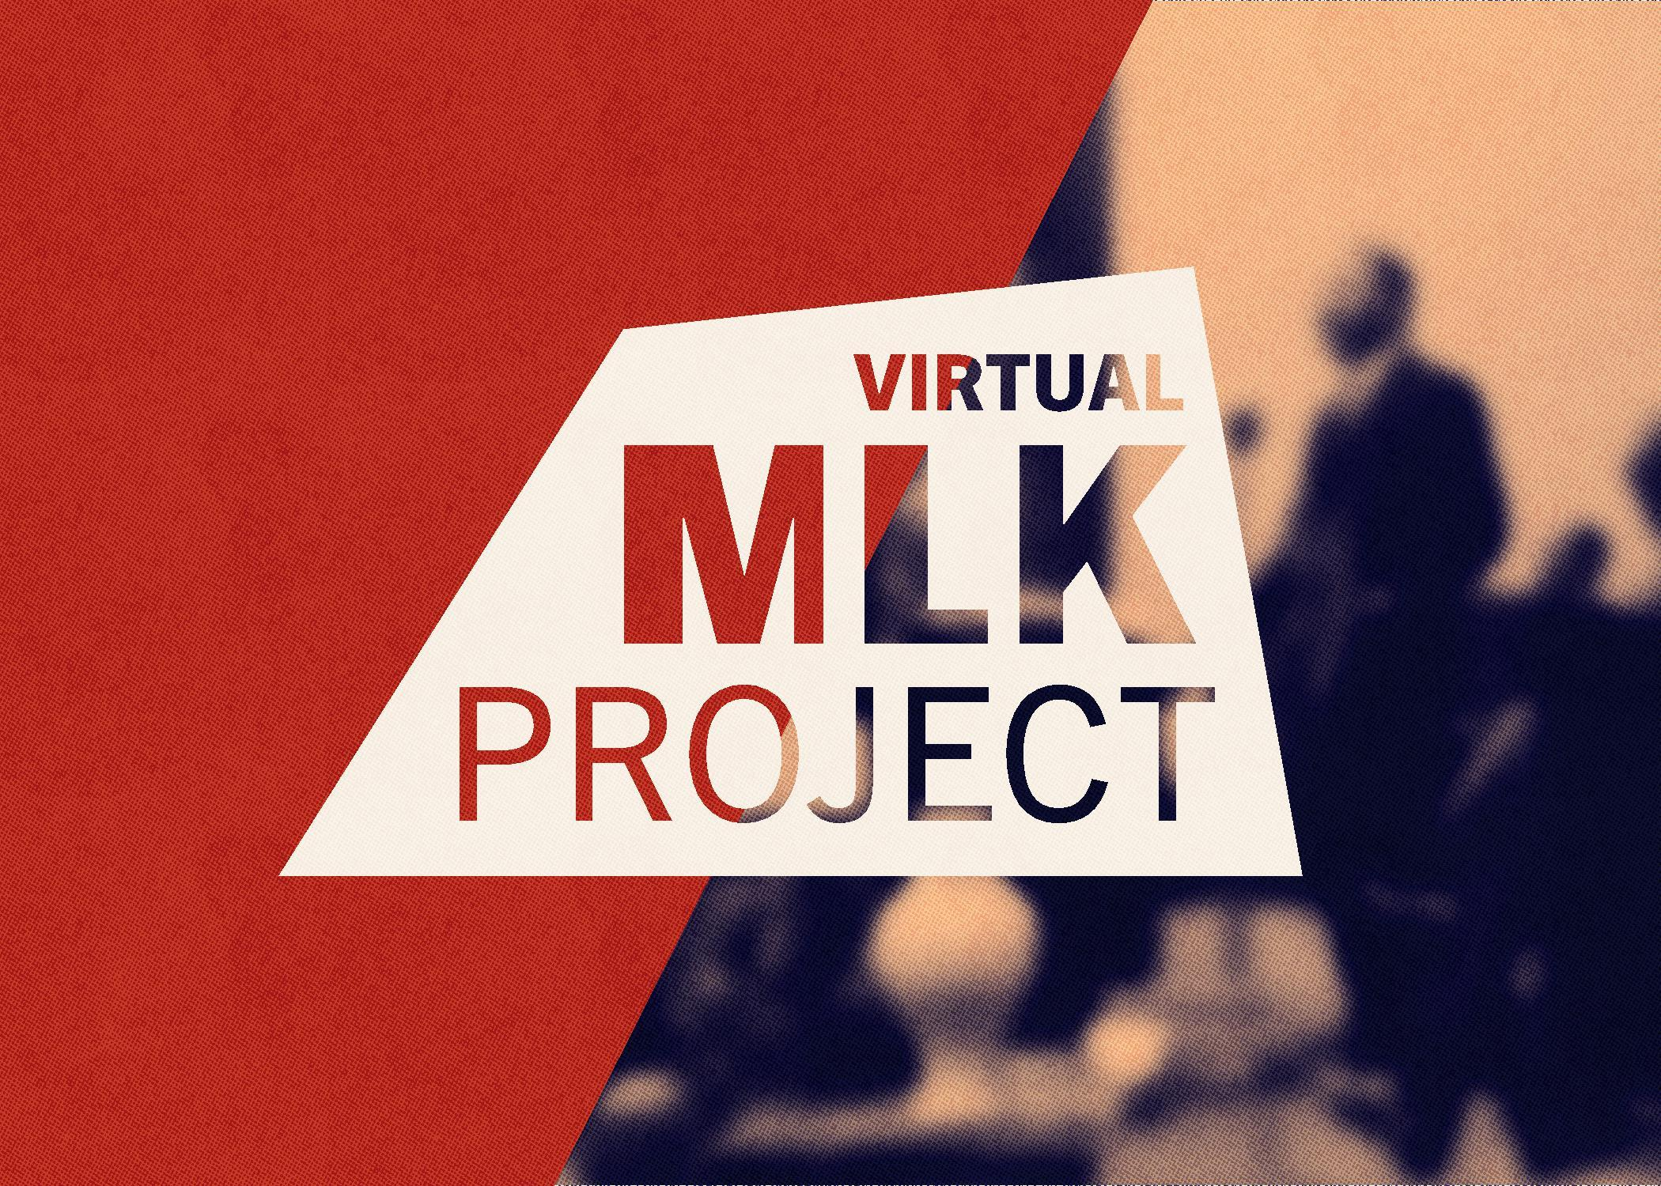
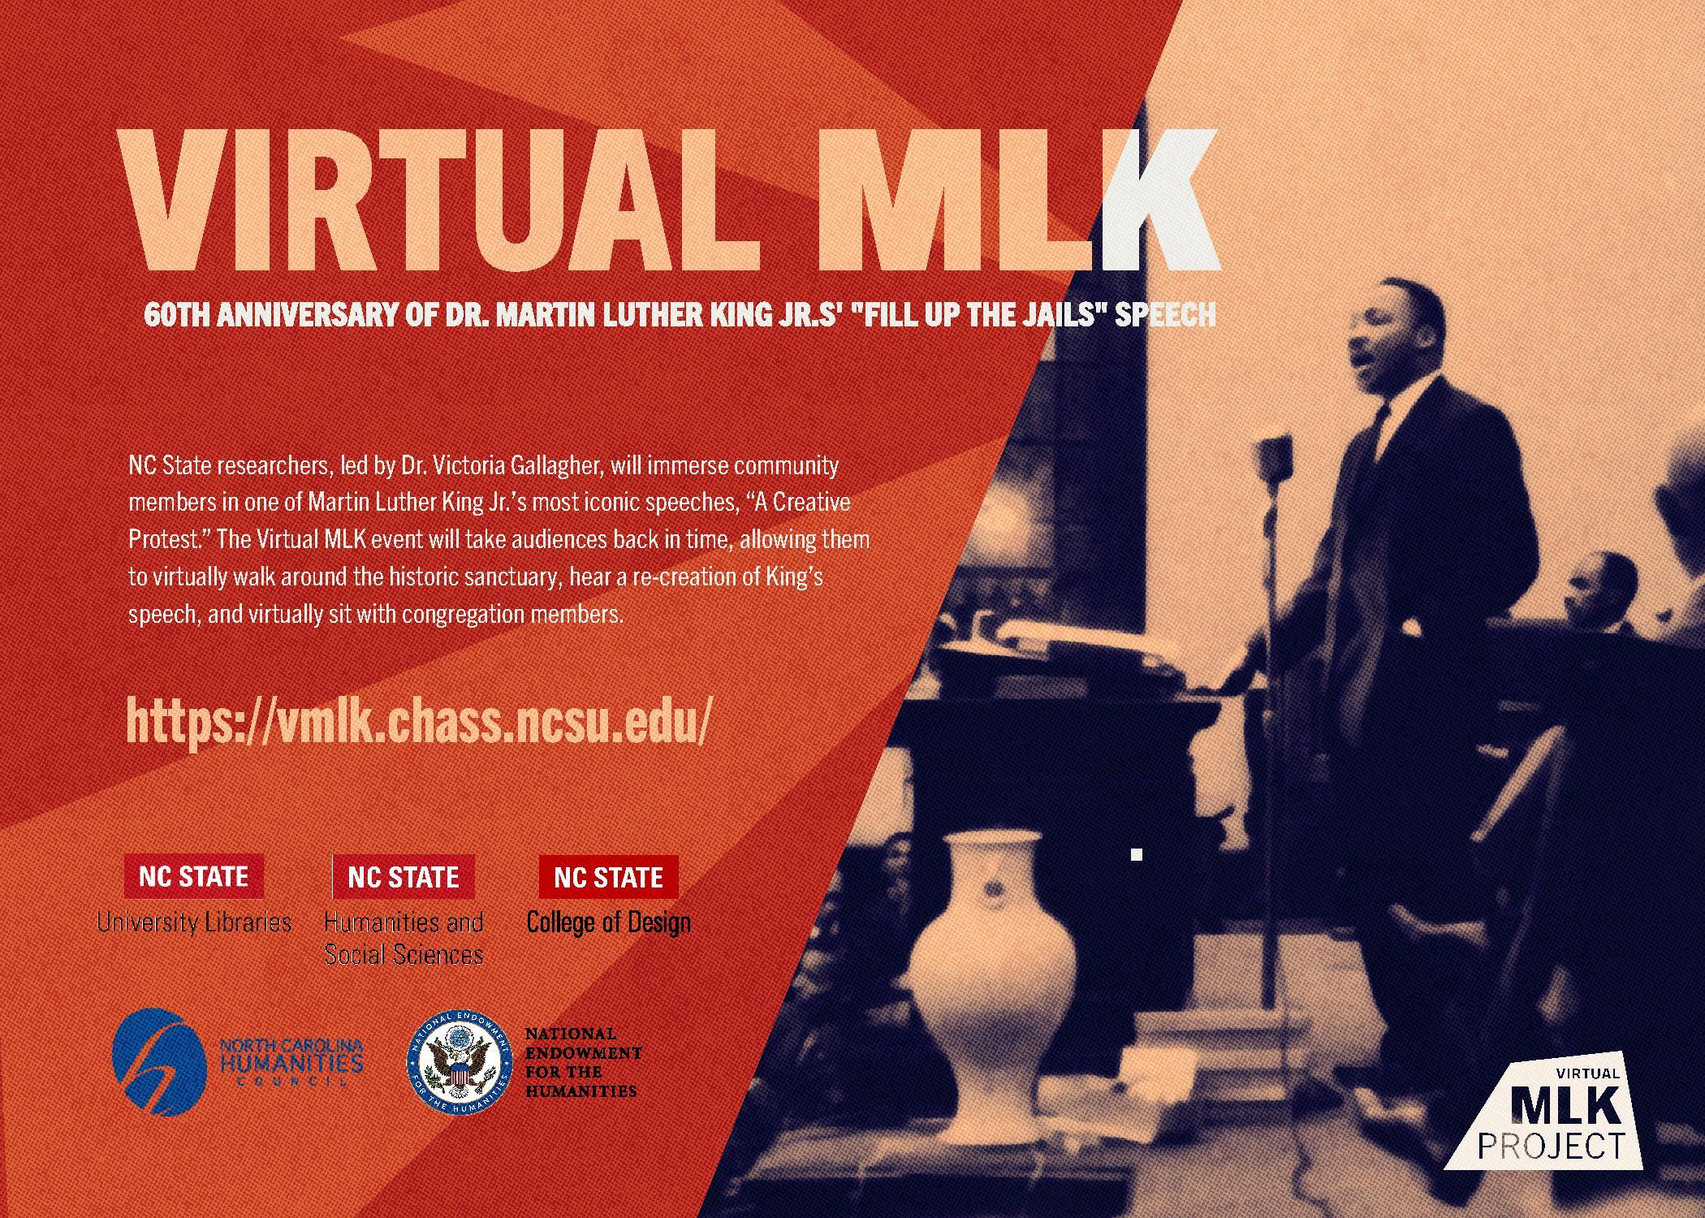
Appendix D: Letter to Local Churches

Good morning ______________________________________________,

You are cordially invited to be a part of Civil Rights history at the North Carolina State University’s Hunt Library on Saturday, Feb. 15th. Join us as we commemorate the 60th anniversary of Dr. Martin Luther King Jr’s “Fill Up the Jails” speech. This event is a full day of free, public events featuring a virtual reality experience of one of Dr. King’s most iconic speeches. Other events include a choral performance, family activities, guided tours, and a community discussion on advocacy.
NC State researchers, led by Dr. Victoria Gallagher, will immerse community members in King’s “Fill Up the Jails” speech—originally titled “A Creative Protest” and delivered on February 16, 1960 at White Rock Baptist Church in Durham. In the Hunt Library’s 270-degree visualization space, visitors can virtually walk around the historic White Rock sanctuary, hear a re-creation of King’s speech, and virtually sit with congregation members.

Visitors may sign up for a guided tour of this vMLK exhibition, led by project leaders Dr. Victoria Gallagher and Dr. Derek Ham. Tours are approximately 90 minutes with moderate walking and standing. Self-guided tours will also be available throughout the duration of the event.

Events at the Hunt Library (1070 Partners Way, Raleigh) include:
10:00 a.m.-3:00 p.m. Self-guided tours throughout the day

10:00 a.m.-11:30 a.m. Family activities

11:00 a.m. & 1:00 p.m. Guided tours of the exhibition led by Dr. Victoria Gallagher and Dr. Derek Ham. Space is limited; pre-registration required at go.ncsu.edu/MLKtour

11:30 a.m.-1:00 p.m. Food for purchase from Piri Catering

12:00 p.m.-1:00 a.m. Choral performances by the White Rock Baptist Church Choir and NC State’s Uninhibited Praise Gospel Choir

12:45 p.m. & 1:45 p.m. Book introduction and signing with Dr. Joyce Blackwell

2:00 p.m. Community discussion on advocacy

The vMLK project will soon be available to K-12 classrooms, helping students understand Civil Rights history and current-day advocacy.

The day of events is co-sponsored by the NC State University Libraries, the College of Humanities and Social Sciences, and the College of Design and is made possible with support from the National Endowment for the Humanities and the North Carolina Humanities Council.
You can find a copy of the invitation attached. We hope you’ll join us!

All best wishes,
Dr. Victoria Gallagher and the vMLK Team

Appendix E: Press Release

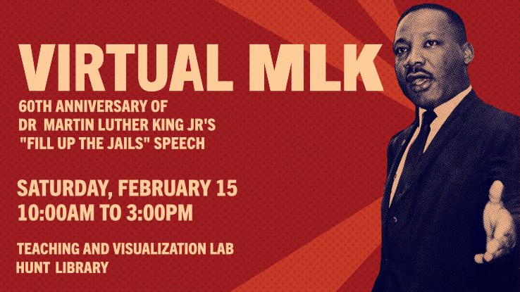
Experience King’s iconic 1960 speech in Virtual Reality, plus choral performances, family activities, guided tours, and community discussion

Be a part of Civil Rights history at the Hunt Library on Saturday, Feb. 15. with a full day of free, public events featuring a virtual reality experience of one of Dr. Martin Luther King Jr.’s iconic speeches. Other events include a choral performance, family activities, guided tours, and a community discussion on advocacy.
NC State researchers, led by Dr. Victoria Gallagher, will immerse community members in King’s “Fill Up the Jails” speech—originally titled “A Creative Protest” and delivered on February 16, 1960 at White Rock Baptist Church in Durham. In the Hunt Library’s 270-degree visualization space, visitors can virtually walk around the historic White Rock sanctuary, hear a re-creation of King’s speech, and virtually sit with congregation members.

Registration for the guided tour of the vMLK exhibition, led by project leaders Dr. Victoria Gallagher and Dr. Derek Ham, are now full. Tours are approximately 90 minutes with moderate walking and standing. Self-guided tours will be available throughout the duration of the event.

Events at the Hunt Library (1070 Partners Way, Raleigh) include:

10:00 a.m.-3:00 p.m. Self-guided tours throughout the day

10:00 a.m.-11:30 a.m. Family activities

11:00 a.m. & 1:00 p.m. Guided tours of the exhibition led by Dr. Victoria Gallagher and Dr. Derek Ham. Space is limited; Registration is full.

11:30 a.m.-1:00 p.m. Food for purchase from Piri Catering

12:00 p.m.-1:00 p.m. Choral performances by the White Rock Baptist Church Choir and NC State’s Uninhibited Praise Gospel Choir

11:00 a.m. & 1:45 p.m. Book introduction and signing with Dr. Joyce Blackwell

2:00 p.m. Community discussion on advocacy

The vMLK project will soon be available to K-12 classrooms, helping students understand Civil Rights history and current-day advocacy.

The day of events is co-sponsored by the NC State University Libraries, the College of Humanities and Social Sciences, and the College of Design and is made possible with support from the National Endowment for the Humanities and the North Carolina Humanities Council.

Appendix F: Media Pitch to WRAL

Good Morning Mikaya and Adam,

I hope your new year has started on a great note. The NCSU Virtual MLK Project has an exclusive story pitch for WRAL News' February coverage of African American history. In advance of the February 15 vMLK event at NC State's Hunt Library, we would like to invite you to an exclusive preview (for WRAL only) of the virtual experience, remembering King's visit and speech in a Durham, NC Church in February 1960. This could be a compelling segment during your Sunday morning show, in advance of the public event.

Most people are not aware that Dr. King delivered the iconic speech, originally titled “A Creative Protest” but later referred to by King and others as “Fill Up the Jails,” on February 16, 1960 at White Rock Baptist Church in Durham. The Virtual MLK (vMLK) event will take audiences back in time by leveraging the James B. Hunt Jr. Library’s 270-degree visualization capabilities, allowing them to virtually walk around the historic sanctuary, hear a re-creation of King’s speech, and virtually sit with congregation members.

We could provide video clips that give you an idea of what the congregation experienced and what the vMLK experience will provide to audiences. Dr. Victoria Gallagher, one of the project researchers, is available to come on set for an interview or do taped interviews if you would like. She's great on camera and can also discuss how this project promotes social advocacy. We will arrange an interview with someone from White Rock Baptist Church if you would like. We can also arrange for you to experience the project yourself at Hunt Library. Just let us know.

Again, we're pitching the exclusive preview to you first. If you decide to pass, please let us know at your earliest convenience. Looking forward to hearing from you and thank you for taking time to consider this.

Kind regards,

Melody

