NEH Virtual MLK Workshop:

Summary Report

Compiled by
Victoria J. Gallagher and Max Renner

Table of Contents
Introduction and Overview 3
Virtual MLK Workshop Executive Summary 4
Workshop Schedule 7
Overview of Assessments 9
Summary of Written Feedback 9
Summary of Survey Responses 11
Outcomes & Next Steps 14
Appendix: Survey Response Graphs 16
Question 1: Overall, how would you rate this exhibit?
Question 2: Check the words that best describe your experience of the vMLK exhibit.
Question 3: Which aspect of the exhibit did you like best?
Question 4: Did the order in which you experienced the vMLK project flow cohesively?
Question 5: Please describe your overall experience with the vMLK project.
Question 6: As a result of this exhibit, I feel more knowledgeable about:
Question 7: I most closely identify as (gender):
Question 8: I most closely identify as (race/ethnicity):

Introduction and Overview

The Virtual Martin Luther King (vMLK) Project engages individuals and groups in the hermeneutic act of experiencing and interpreting what was, what is, and what has never been in relation to public address and civic (e.g., racial) transformation. Just days after the start of the Greensboro sit-ins in February 1960, Dr. Martin Luther King, Jr. delivered what would become a widely influential speech titled, “A Creative Protest.” The speech, commonly known as the “Fill Up the Jails” speech, was delivered on February 16, 1960 in Durham, NC. It marked the first time Dr. King openly encouraged activists (promising the full support of the Southern Christian Leadership Conference) to disrupt and break the law through non-violent confrontation even if it meant ‘filling up the jails’ and the speech served to catalyze the movement. Despite the historical and rhetorical significance
of this speech, no audio recordings have been found and the original location of the speech, White Rock Baptist Church, was torn down just 7 years later in 1967 to make way for the Durham Freeway.

The Virtual Martin Luther King Project began as a partnership between the church congregation and local communication scholars. The result was a public recreation of King’s speech at the current church on June 8, 2014. Featuring a voice actor, the recreation event attracted over 250 people, including individuals who had attended the speech in 1960, area politicians and activists, members of the Durham Ministerial Alliance, congregation members, and members of the NC State community. Based on the sound recordings of the recreation, the vMLK Project utilizes advanced digital and audio technologies to afford scholars, students and citizens an opportunity to engage this speech through presentation of six components: 1) historic context, 2) individual listening and 3) collective sound experiences, 4) virtual reality and 5) gaming platform experiences, and 6) the “your creative protest” feedback opportunity.

Since the completion of the first phase of the project in 2015, over 1000 undergraduate students per academic year experience this multi-faceted project as part of their public speaking curriculum and/or visual rhetoric course, making it one of the most influential digital pedagogy projects at NC State and the largest user of the Teaching and Visualization lab and Creativity Studio spaces at Hunt Library. Additionally, the vMLK project was presented in October 2017 at the National Museum of American History at the Smithsonian as part of the ACCelerate Festival to much acclaim from visitors who were asked to complete online surveys about their experience. The vMLK exhibition at the Smithsonian marked the first time a communication scholar exhibited a project at the Smithsonian. Additionally, the North Carolina Humanities Council awarded Dr. Gallagher and the vMLK project team the Harlan Joel Gradin Award for Excellence in Public Humanities and the project has been featured as an exemplar in a Washington Post article on Digital Humanities projects.

Investigators on the Virtual Martin Luther King, Jr. Project (vMLK) began with a digital humanities vision: to develop an immersive recreation (an interactive, digitally rendered experience) of MLK’s “Fill up the Jails” speech, a historic moment in the US civil rights movement. The vMLK project serves to expand understanding for scholars, students, and public audiences in regard to the following: 1) specific aspects of civil rights history in North Carolina, 2) the nature of civic and political engagement, both in the 1950s and 1960s and today, 3) the transformative and affective aspects of public address, particularly in relation to issues of racial justice, and 4) the importance of sound in developing transmedia immersive experiences.

The project’s format and design is that of a transmedia project utilizing web tools, gaming and virtual reality platforms, and digitally rendered immersive audio and visual models to engage the public in humanities content. This content is made available to students, citizens, and scholars through the interactive components of the official project website, through the immersive audio and visual experiences/exhibitions at the 2016 IMLS National Medal award-winning Hunt Library, and at other public lectures, exhibitions and events.

Virtual MLK Workshop Executive Summary

In September of 2019, Dr. Victoria J. Gallagher, along with her colleagues, Dr. Derek Ham and Dr. Keon Pettiway, led a 1.5 day workshop for humanities advisors, library and museum partners, scholars and community partners to assess the vMLK Project, to assist in developing priorities for the next phase of the project, and to consider the project contributions including transferability, access, and the future of intellectual work in relation to digital projects. This workshop was funded and supported through the NEH Foundation’s Digital Projects for the Public Production Grant and the NC State Libraries.

Goals
The vMLK Workshop at NC State was a key part of the larger NEH funded vMLK production process. The goals of the workshop included the following:

1. To review the production of the project components with humanities advisers, museum, library, and community partners and with interested colleagues.

2. To assess how well the project is meeting production goals and to receive consultation and advice as we prepared for the production of the 60th anniversary of the speech exhibition in February 2020 and planned for the second year of the grant cycle.

3. To articulate and evaluate the best practices emerging from the vMLK project and to determine how best to make those available and accessible to advisers, partners, and scholars.

Summary of Discussion/Assessment:
Model of Digital Humanities Collaboration

Participants in the Workshop agreed that the vMLK project offers a productive model for large scale digital humanities projects by: 1) foregrounding theoretical rigor, 2) engaging in iterative processes for developing projects and partnerships, and 3) exploring the potential for accessibility of digital humanities projects on a variety of levels.

Foregrounding theoretical rigor:
Several scholars mentioned frustration in digital humanities projects that sold their potential short due to a lack of theoretical contribution. By contrast, participants agreed that the vMLK project works because the theoretical frameworks on which it relies are compelling and are evident in the design of the project. In fact, the vMLK project was discussed as a model for thinking through how the design of digital humanities scholarship should be informed by a dedication to foregrounding theoretical rigor within design. In the case of the vMLK project, Kim Gallon’s framework of technologies of recovery and Gallagher et. al. conceptualization of public address as embodied experience are utilized as frameworks for the modes of engagement as well as the goals and design of the project.

Iterative, invitational process:
Theoretical rigor integrated through project design is a key consideration within digital humanities work but so is invitationally engaging with partners. In particular, the importance of an iterative process for development of both the project elements and the project’s partnerships, was noted as a crucial element that sets the vMLK project apart and contributes to its success on all levels. The process and consideration of interdisciplinary engagement (within, across and outside of the university) demonstrated by the vMLK project was also noted as providing a useful model for others who are exploring/developing these kinds of projects.

Accessibility and sustainability
A valid critique/hindrance related to doing digital humanities work is the challenge of accessibility, particularly a project as heavily reliant on technology as the vMLK project. Some of the assets may be more or less transferable and replicable, but not every institution will have these same kinds of technological resources/setups which makes transferability a challenge. Additionally, it can make such projects difficult to find or access even if scholars, students and citizens may be aware of them. These concerns about sustainability, accessibility, and the potential for transformative impacts of public DH projects drove much of the conversation on the second day of the workshop.

Summary of Workshop Evaluation and Outcomes:
1. The vMLK project is a commendable example of a scholarly production that is multi-faceted and layered in its articulations; participants in the workshop particularly noted the project’s “kit of parts” design as a significant strength.

2. The vMLK project offers an exceptional model for engaging in iterative interdisciplinary research that foregrounds historical, contextual engagement rendered through digital transmedia development.

3. The vMLK project serves as an exemplar for projects seeking to develop collaborative relationships with communities, showcasing how to work iteratively to incorporate and respond to the priorities of community partners and organizations.

4. vMLK project assets, based on the feedback received through the workshop, have been redeveloped, between November 2019 and February 2020. The redevelopment included enhanced and updated exhibition design, branding and logo design. These were featured at the highly successful public exhibitions of the project on January 19, 2020, and for the 60th Anniversary of a Creative Protest exhibition and celebration on February 15 and 16, 2020. Further VR and website enhancements and updates are scheduled for Summer 2020. See Image collages.

5. The vMLK project team, based on feedback from the workshop, is pursuing publication of audience feedback results in traditional academic venues (see: https://www.tandfonline.com/eprint/CKRY3MDFXZPQQBMXRUZR/full?target=10.1080/03634523.2020.1735642
Article in Communication Education) and presenting research at other universities and academic outlets. Additionally, vMLK team members are striving to make assets accessible/available for a wider array of audiences, and to document the story of this project through both traditional publication (e.g., a book proposal through University of South Carolina Press) and less traditional platforms (including community events and collaborations).

6. The vMLK project team is working with library partners to develop an inter-institutional academic platform for digital humanities projects to facilitate thoughtful engagement with these kinds of projects and to make them more accessible/legible to academic structures as well as communities and public audiences.

Workshop Schedule

The 1.5 day workshop was structured in order to achieve the three primary goals (reviewing the production of the project components, assessing the project assets in order to advance further development, and articulating the best practices emerging from the vMLK project for advisers, partners, and scholars).

To this end, the schedule for the first day was dedicated to both a thorough review of the project’s history, development, assets, and community engagement work, coupled with a consideration of how each element of the project may/should/could be iterated going forward. Throughout these sessions, participants were offered spaces to engage with each element of the project and were asked to evaluate the project in group discussion at the end of each session as well as in the Feedback and Debrief session at the end of the day.

Day 1

VMLK Exhibition Experience | Walking Tour: This tour of the exhibition included each of the six experiences: historical, listening, collective sound, VR, simulation, and Share Your Creative Protes
Recollecting and Recreating Historical Archival Materials | Archival Collection: This session was when the project leads offered an overview of how the archival materials were collected and elaborated on the collaboration with our community partner, the White Rock Baptist Church.
Technical Review | Gaming Simulation and VR: This discussion centered on the development of the technological and architectural models.
Lunch and Community Partnership | Lunch With Community Partners: The Workshop participants were joined by several members of the White Rock Baptist Church during the catered lunch to learn more about their experience with and assessment of the project.
Website Development | Accessibility and Progression: This session focused on the development of the website with attention to potential future iterations geared more toward accessibility and collaboration.
Public Exhibitions | Collaborative and Public Exhibitions: This session began with highlighting previous public exhibitions and institutional collaborations, in order to consider future exhibitions and partnerships.
Pedagogy | Pedagogical Applications: Dr. Elizabeth Nelson and several current instructors utilizing the project discussed their insights and development of teaching materials.
Debrief and Reactions | The first day, concluded with sharing initial reactions and assessments based on guiding questions and other prompts.

Recommendations and extensions were the principles undergirding the second day of the workshop. In particular, each session was a more open format that began with guiding questions and brief presentations in order to facilitate cross disciplinary and inter-institutional insights regarding transferability of resources, community engagement practices, and methods for considering digital humanities and public facing scholarship.

Day 2

Light Breakfast and Discussion: Transference | This session emphasized a variety of questions related to how this project, as well as digital humanities projects and technologies, more broadly, can be shared and transferred among institutions.
Leadership and Organizational Structure | This session was a combined presentation and discussion forum, some of the driving questions and concerns included: How has the leadership and organizational structure worked? What might be other options for leading and organizing a project such as this? What are the big ideas that have emerged that can reach across institutions and how might they be pursued?
Scholarship, Community, and Public Engagement | The focus of this session was on the ways in which the vMLK project team and scholars in general can support and pursue the development of future projects.
Final Thoughts and Reactions | The workshop concluded with an open discussion of thoughts, questions, and observations about the project, the process, and potential for collaborations. Each participant had an opportunity to articulate their parting ideas about how to further develop their own projects and engagements.

Overview of Assessments

Summary of Written Feedback

The assessment of the project came in two forms 1) notes taken from discussions throughout each day as well as specific written responses regarding the project, development, and future contributions and 2) survey results that participants of the workshop were asked to complete after the tour of the project assets. The outcomes of the discussions are listed in the Overview of Outcomes section and the feedback from the survey is detailed in the Survey Evaluations section.

Workshop participants were actively involved throughout the 1.5 days in reviewing, assessing, and evaluating project aspects and in generating ideas and takeaways. Among the wide range of best practices and takeaways participants addressed, two of the key contributions of the project that emerged from discussions within this workshop were: 1) the model the vMLK Project provides for how to do a multi-faceted project that engages a broad range of publics in humanities-based knowledge and 2) the model the vMLK Project provides for how to collect, document, publish, and provide access to large scale digital projects.

Thinking About Public Humanities Knowledge

Considering both the scope and potential of public humanities scholarship was a point of concern among discussants. Concerns were raised regarding the scope of public humanities, or public facing scholarship and the forces that conspire to reduce these projects to exclusively academic/scholarly endeavors rather than valuable and valued engagements with communities. This potential attenuation of public humanities projects represents an ethical and in some cases artistic imperative; any public facing project should be thinking about community.

Critically, discussants pointed to not only the community engagement work of the vMLK project, with the White Rock Baptist Church, as a model for iterative, dynamic collaboration, but also to this workshop as an important feature of building community. The workshop itself was framed as a model for thinking through how to build community while doing this kind of public facing work; how can/should scholars be connecting with and building communities is an intellectual production itself (one that the workshop demonstrated and allowed for). Pushing the boundaries of how/what we consider to be intellectual production within academia, was a key feature of these discussions.

Another insight that came from these discussions was the model of review that vMLK demonstrates. Much of the work within academia is fundamentally predicated on the notion of peer review from colleagues within and across disciplines. Yet what often is left underappreciated/unconsidered is that this peer review comes not only from colleagues when engaging in this type of work, but from communities and audiences that public facing projects engage. Thinking about how to appreciate as well as contend with this kind of labor is a model that the vMLK project was noted as highlighting (particularly given the discussions with the White Rock community members in the workshop session detailing this reflexive process).

Model of Digital Humanities Collaboration

In addition to articulating concerns about as well as methods for integrating public engagement, scholarship, and pedagogy, participants indicated three key benefits the vMLK project offers as a model for how to think through large scale digital humanities projects (how to actually do something like this): 1) foregrounding theoretical rigor, 2) engaging in iterative processes for developing projects and partnerships, and 3) exploring the potential for accessibility of digital humanities projects on a variety of levels.

One comment that was brought up a number of times throughout the workshop was the concern surrounding the level of rigor that digital humanities projects offer. Several scholars mentioned frustration in previously seeing digital humanities projects that sold their potential short due to a lack of theoretical contribution. By contrast, participants articulated that the vMLK project works because the theoretical frameworks on which it relies are compelling and are evident in the design of the project. In fact, the vMLK project was discussed as a model for thinking through how the design of digital humanities scholarship should be informed by a dedication to foregrounding theoretical rigor within design. In the case of the vMLK project, Kim Gallon’s framework of technologies of recovery and the conceptualization of public address as embodied experience are utilized as frameworks for the modes of engagement, goals and design.

Foregrounding theoretical rigor into design is a key consideration within digital humanities work but so is engaging in a process that is invitational to potential partners. In particular, the importance of an iterative process for development, of both project and partnerships, was a crucial element that was noted by participants as setting the vMLK project apart in terms of its success on all levels. The process and consideration of interdisciplinary engagement (within, across and outside of universities) that the vMLK project demonstrates was emphasized as providing a useful model for thinking through how to conduct these kinds of projects.

Additionally, when thinking about how to develop projects across institutions and the tremendous resources required to do so, accessibility of these projects came to the fore. A serious and extremely valid critique/hindrance of doing digital humanities work is the challenge of accessibility, particularly a project as heavily reliant on technology as the vMLK project. Some of the assets may be more or less transferable and replicable, but not every institution will have these same kinds of technological resources/setups which makes transferability a challenge. Additionally it can make such projects difficult to find or access even if scholars may be aware of them. These concerns about sustainability, accessibility, and the potential for transformative impacts of public DH projects drove much of the conversation on the second day.

Summary of Survey Responses

At the end of the tour of the vMLK Exhibition on the first morning of the workshop, participants were given the opportunity to write reflections on white boards spread around the Creativity Studio and to complete a brief survey on ipads placed around the room. Prompts on the white boards were as follows (the first three prompts are directly from the speech text): “A Creative Protest Is,” “An Idea Whose Time Has Come,” and “The Origin of My Dream.” Additional written responses were categorized after the fact under the following “Reflecting About This Experience,” and “General Feedback.” Photographs were taken of each of the white boards after the session, and then entered into a google sheet. The ipad survey responses were collected/collated in a google form and are summarized below. Eight individuals completed the ipad survey.

This is the manner in which we have collected feedback at every vMLK Exhibition, whether for pedagogical purposes or for public audiences. Sharing the responses of the small data set from the workshop provides a sense of how a specialized audience, namely our partners, scholars and colleagues responded to the project as presented.

Question 1: Overall, how would you rate this exhibit? (multiple choice options: poor, average, excellent).

In responding to and reflecting on the exhibition, each of the 8 participants listed their experience of the exhibition as “excellent” out of the options of poor, average, or excellent.

Question 2: Check the words listed below that best describe your experience of the vMLK exhibit (multiple selection options: challenging, confusing, dull, clearly focused, worthwhile, stimulating, entertaining, informative)

Of the responses from participants, the most common terms associated with the vMLK experience were “informative” (8 responses), “stimulating” (7 responses), and “worthwhile” (7 responses). Of the other terms, slightly less than half of the respondents indicated that the experience was “entertaining” (3 responses), and “focused” (3 responses). Additionally, “challenging” and “superficial” were terms that received one response each. From these results, it is clear that the majority of respondents found the vMLK experience to be informative, stimulating, and worthwhile and no respondents found the experience confusing or dull.

Question 3: Which aspect of the exhibit did you like best?

This question allowed respondents to select options to describe the part(s) of the exhibit that they liked best. From the preliminary collected responses, it seems clear that the collective listening (3 responses), Counter Histories Documentary (2 responses), and project documentaries (2 responses) are the most liked features of the exhibit; archival photographs and Your creative protest experiences each received one response, respectively.

Question 4: Did the order in which you experienced the vMLK project flow cohesively? If not, how can it be improved?

This question allowed respondents to articulate how they felt about the flow of the experiences. Respondents were also able to indicate their suggestions for improvement. Of the eight respondents, 6 indicated they had a positive experience with the flow of the exhibit and 2 indicated they had a mixed response in terms of the flow of the experience. More specifically, respondents appreciated the contextual work and narrative aspect that was provided by the project. The main feedback was in regard to the VR experience. The feedback was mixed on this VR component, some said that they appreciated the VR coming last, while another respondent indicated that the VR component felt segmented after the group dynamics of the other components.

Question 5: From start to finish, please describe your overall experience with the vMLK project.

- Even though I've worked on the vMLK project (animation development side) this overall experience has taught me things that I didn't even know about the project or the history, and allowed me to see the variety of connections, stakeholders, and community engaged in the project.
- The VR experience did not live up to my expectations, perhaps because of the order of the tour of assets.
- The experience was a timely contrast to modern communication.
- I really enjoyed hearing who was here and am excited about the community partners present such as for the Smithsonian, Durham, and the church members. It is amazing to have Mary here, who attended the original speech! I got the chills even during the opening documentary describing the vMLK project and am just so excited at the potential for students to experience this. Partners who talked about bringing this to the K-12 classroom really excited me.
- Very good- it was an outstanding speech and the entire experience made me think about the relationship between simulation, history, memory, and immersion in new and productive ways.
- Inspiring on a personal, scholarly, and civic level.
- I knew about the website and had experienced that first. It was inspiring to see/meet the people who the project is about, or who created it. Then, experiencing the materials was the icing on the cake, especially the option of a variety of experiences.
- It was a great informative learning experience

Question 6: As a result of this exhibit, I feel more knowledgeable about (Please check any that apply):

This question asked respondents to indicate what they feel more knowledgeable about after the vMLK experience. The data presented, in the bar graph above, indicates how many respondents selected each option as something they felt more knowledgeable about.

The results indicate that, after the vMLK experience, most respondents felt most knowledgeable about “The 1957 Royal Seven Sit-in in Durham, NC; “How it might have felt to hear Dr. King speak King’s 1960 speech titled, ‘A Creative Protest [Fill Up the Jails]’”; and “How it might have felt to sit or stand in the White Rock sanctuary.”

Question 7: I most closely identify as (gender):

These results indicate that the majority of respondents identify as male (6 respondents) and 2 identified as female.

Question 8: I most closely identify as (race/ethnicity):

This question asks respondents to identify their ethnicity. The results indicate that the majority of respondents identified as White/Caucasian (5 respondents), 1 identified as Black/African American, 1 identified as Hispanic/Latino, and 1 identified as Native American.

Outcomes & Next Steps

Next Iterations of vMLK

From this Workshop we have begun planning and executing several preliminary as well as long term developments for the vMLK project. The first of these changes stems from the feedback about the overall flow of the exhibition. In Fall of 2019, the project worked with a Design studio seminar to undergo an Exhibition review for the project. This review combined feedback from previous exhibitions, the NEH Workshop as well as the design students’ expertise in order to consider best practices for the exhibition experience; with particular focus on how audiences experience moving through the exhibition and spaces. This has led to shifts in organization of the exhibition, design and branding development as well as development of consistent aesthetics. This exhibition Review proved invaluable in developing the 60th Anniversary event held on February 15th, at Hunt Library, where we continued the collection of this kind of feedback with over 500 community members attending.

In addition to this exhibition development, the project has begun preliminary consideration for the development of a project mobile app; considering what affordances and constraints this type of asset extends to audiences. Extending from these considerations and previewing a consideration of accessibility for the project, the project team has worked to make the vMLK project a permanent installation at Hunt Library or permanent special collections piece (potentially as either self guided or monthly event).

Part and parcel to establishing this installation will be the further development of the project’s VR experience; this development will critically involve introductory contextual information into the new narrative arc to make this asset more mobile. This implementation will allow for the VR experience to be delivered to schools, public institutions, and community organizations more concisely and effectively. As a component of this VR work, the project will be creating specific pedagogical content and materials for K-12 classrooms in the summer of 2020.

Accessibility

Extending from the Workshop discussions of how to make vMLK available in ongoing ways, the project team has begun thinking about the extensions for pedagogical and professional accessibility.
In terms of making the project accessible to other institutions, NC State Libraries are now in conversations with Duke and UNC about collaborative development of a platform for shared imprints of these kinds of projects, ideally allowing people to check out this content in order to readily bring it to their universities and classrooms. In keeping with this goal, the importance of affording K-12 classrooms the opportunity to engage with this project is at the forefront of the agenda. We have collaborated with the 360 Learning Lab in Raleigh, NC as a prototype for modeling how these VR assets can be mobilized and brought to classrooms. The project has already collaborated with the Learning Lab at two community/church events in order to bring the project to congregations and their surrounding communities.

In terms of institutional attainability, it is important to acknowledge that many universities lack the specific technological set up required to exactly transfer these assets and experiences. In order to address this barrier, vMLK project team members have been actively collaborating with Universities to do talks/lectures at other institutions and bringing these assets to institutions by re-composing the assets in ways that are in keeping with the technology available at each institution. Currently, the project is working with the University of Mississippi for a Fall 2020 exhibition and with the University of Montana for a February 2021 exhibition. Additionally, the vMLK project scholarship has further extended to be featured in the RSA Publics for All project, the team has submitted a paper to the Review of Digital Projects, another article regarding vMLK and Public Address in pedagogy is forthcoming in the journal, Communication Education, and is currently drafting a book proposal for an invited edited book collection on the project at University of South Carolina Press.

Community Extensions

One of the most crucial and humbling pieces of feedback received from the NEH Workshop was from our community partners at White Rock Baptist Church. It became abundantly clear from their participation and support that the desire of their community/congregation wanted to be more engaged with the project and for the project to be more actively known within their own communities. As such, we worked in tandem with the congregation and its members to plan and execute the 60th anniversary events, including bringing the Learning Lab 360 to demonstrate the vMLK VR to the congregation on the Sunday anniversary of the speech. With the goal of more fully realizing this partnership, the 60th Anniversary event featured the White Rock Baptist Church members and pastor in a community conversation on advocacy, the White Rock choir performed at the Anniversary event, and the congregation brought nearly 100 participants to the recreation event (making up roughly ⅕ of the participants who attended the 60th Anniversary Exhibition at Hunt Library ).

Appendix: Survey Response Graphs

Question 1: Overall, how would you rate this exhibit? (multiple choice options: poor, average, excellent).
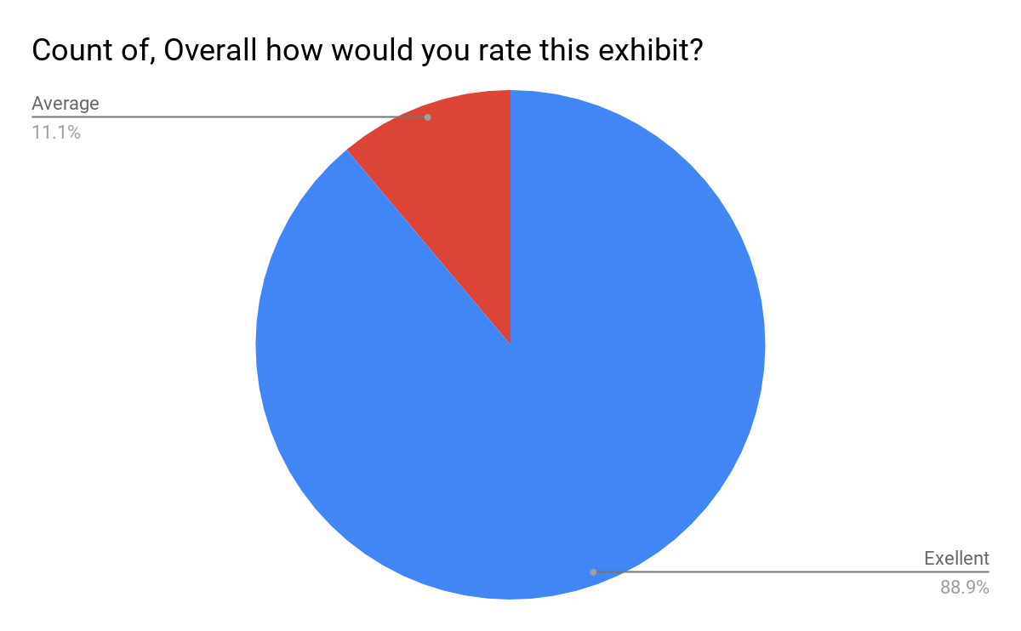

This question asked respondents to reflect on the exhibit. Of the eight responses,
- 100% of respondents rated their experience as “excellent”
- 0% of respondents rated their experience as “average”
- 0% of respondents rated their experience as “poor”

Question 2: Check the words listed below that best describe your experience of the vMLK exhibit (multiple selection options: challenging, confusing, dull, clearly focused, worthwhile, stimulating, entertaining, informative)
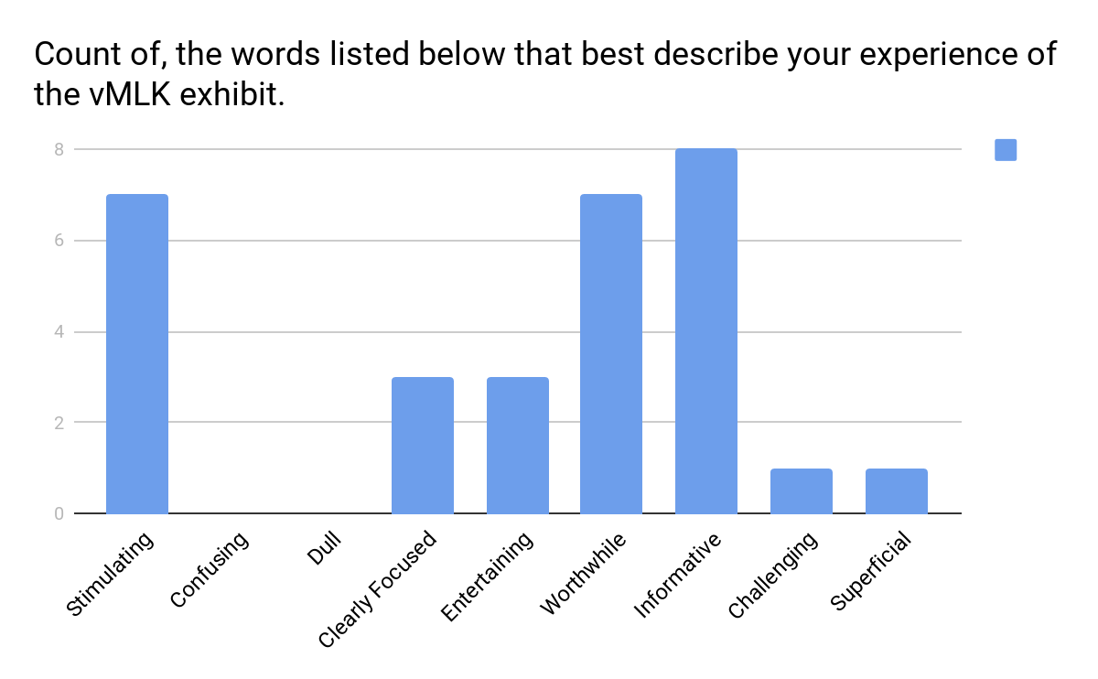
This question allowed respondents to select multiple adjectives to describe their experience(s) of the vMLK exhibit. However, the data presented in the bar graph (above) indicates the number of occurrences of each possible adjective rather than the number of unique combinations of adjectives.

From the total selections of the thirty-three respondents:
- 8 respondents (100%) indicated the experience was informative
- 7 respondents (87.5%) indicated that the experience was stimulating
- 7 respondents (87.5%) indicated that the experience was worthwhile
- 3 respondents (37.5%) indicated that the experience was entertaining
- 3 respondents (37.5%)indicated that the experience is clearly focused
- 1 respondent (12.5%) indicated that the experience was challenging
- 1 respondents (12.5%) indicated the experience was superficial
- 0 respondents (0%) indicated the experience was confusing
- 0 respondents (0%) indicated that the experience was dull

From these results, it is clear that the majority of respondents found the vMLK experience to be informative, stimulating, and worthwhile and no respondents found the experience confusing or dull.

Question 3: Which aspect of the exhibit did you like best? 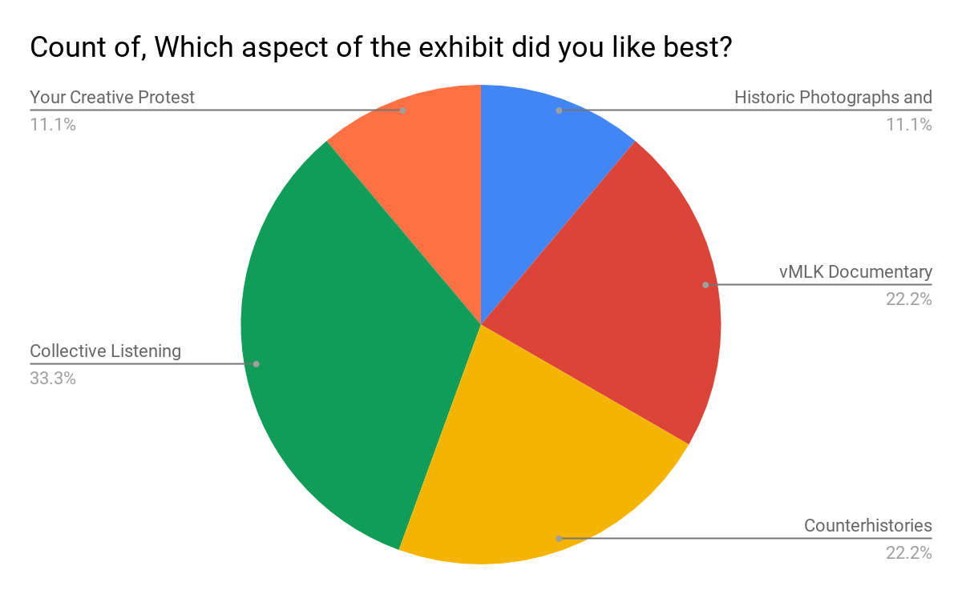

This question allowed respondents to select options to describe the part(s) of the exhibit that they liked best. The data presented in the pie chart indicates the unique combinations of favorite aspects.

From the total selections of thirty-three respondents:
- 33.3% liked the Collective Listening Station best
- 22.2% liked the Counter Histories best
- 22.2% liked the vMLK Project Documentary best
- 11.1% like the archival photographs and images best.
- 11.1% liked both the Your Creative Protest best

From these preliminary results, the collective listening and documentaries are the most liked features of the exhibit.

Question 4: Did the order in which you experienced the vMLK project flow cohesively? If not, how can it be improved?
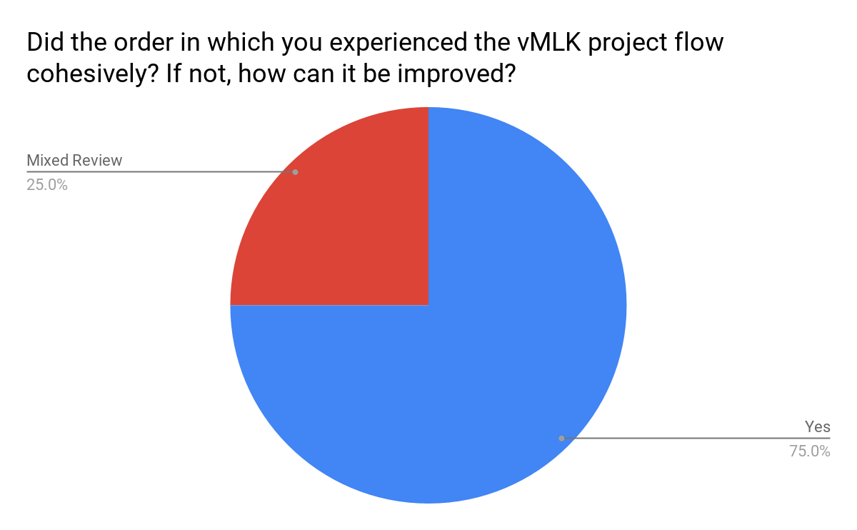

This question allowed respondents to articulate how they felt about the flow of the experiences. Respondents were able to indicate their suggestions for improvement.

From the eight respondents,
- 75% of respondents’ comments indicated that they had a positive experience
- 25% of respondents’ comments signalled a mixed response
- 0% of respondents’ comments indicated a wholly negative response

From the results, respondents appreciated the contextual work and narrative aspect that was provided by the project. The main feedback was in regard to the VR experience. The feedback was mixed on this VR component, some said that they appreciated the VR coming last, while another respondent indicated that the VR component felt segmented after the group dynamics of the other components.

Question 5: From start to finish, please describe your overall experience with the vMLK project.

- Even though I've worked on the vMLK project (animation development side) this overall experience has taught me things that I didn't even know about the project or the history, and allowed me to see the variety of connections, stakeholders, and community engaged in the project.
- I loved the “I am a man” [but the vMLK] VR experience did not live up to that unfortunately.
- The experience was a timely contrast to modern communication.
- I really enjoyed hearing who was here and am excited about the community partners present such as for the Smithsonian, Durham, and the church members. It is amazing to have Mary here, who attended the original speech! I got the chills even during the opening documentary describing the vMLK project and am just so excited at the potential for students to experience this. Partners who talked about bringing this to the K-12 classroom really excited me.
- Very good- it was an outstanding speech and the entire experience made me think about the relationship between simulation, history, memory, and immersion in new and productive ways.
- Inspiring on a personal, scholarly, and civic level.
- I knew about the website and had experienced that first. It was inspiring to see/meet the people who the project is about, or who created it. Then, experiencing the materials was the icing on the cake, especially the option of a variety of experiences.
- It was a great informative learning experience

Question 6: As a result of this exhibit, I feel more knowledgeable about (Please check any that apply):
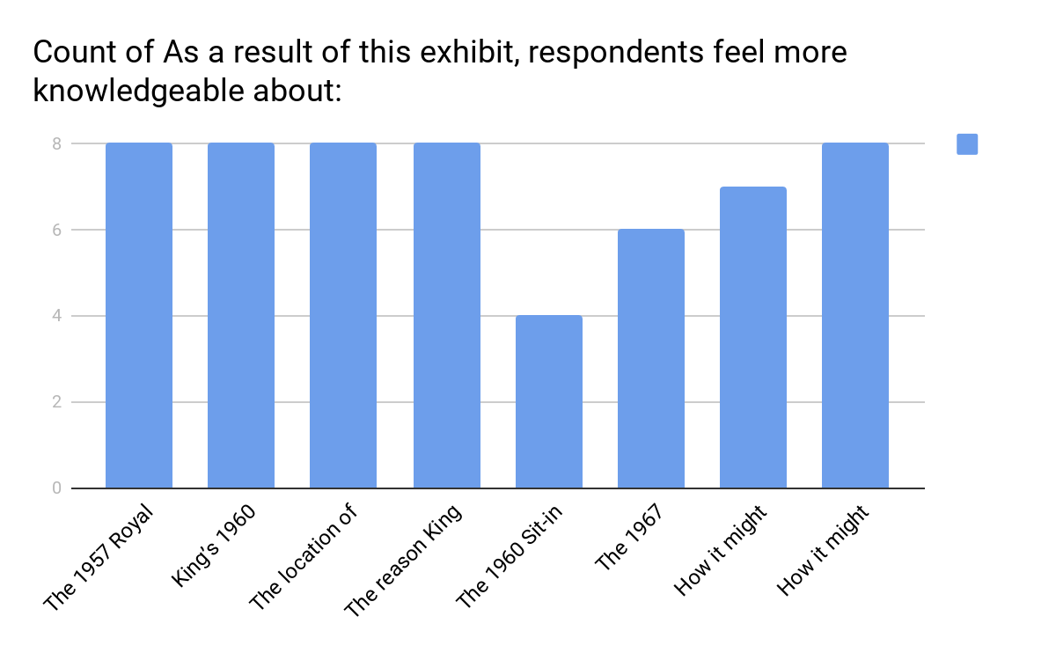
This question asked respondents to indicate what they feel more knowledgeable about after the vMLK experience. The data presented, in the bar graph above, indicates how many respondents selected each option as something they felt more knowledgeable about.

Of eight respondents:
- 8 respondents indicated that they felt more knowledgeable about “The 1957 Royal Seven Sit-in in Durham, NC (27)
- 8 respondents indicated that they felt more knowledgeable about “the reason King gave the 1960 speech in Durham, NC rather than Greensboro” (17)
- 7 respondents indicated that they felt more knowledgeable about “How it might have felt to hear Dr. King speak King’s 1960 speech titled, ‘A Creative Protest [Fill Up the Jails]’”
- 8 respondents indicated that they felt more knowledgeable about “The location of King’s 1960 speech”
- 4 respondents indicated that they felt more knowledgeable about “The 1960 Sit-in at the W.C. Woolworth Lunch Counter in Greensboro”
- 8 respondents indicated that “How it might have felt to sit or stand in the White Rock sanctuary”
- 6 respondents indicated that they felt more knowledgeable about “The 1967 destruction of the White Rock Baptist Church, Durham, NC”

These results indicate that, after the vMLK experience, most respondents felt most knowledgeable about “The 1957 Royal Seven Sit-in in Durham, NC; “How it might have felt to hear Dr. King speak King’s 1960 speech titled, ‘A Creative Protest [Fill Up the Jails]’”; and “How it might have felt to sit or stand in the White Rock sanctuary.”

Question 7: I most closely identify as (gender):
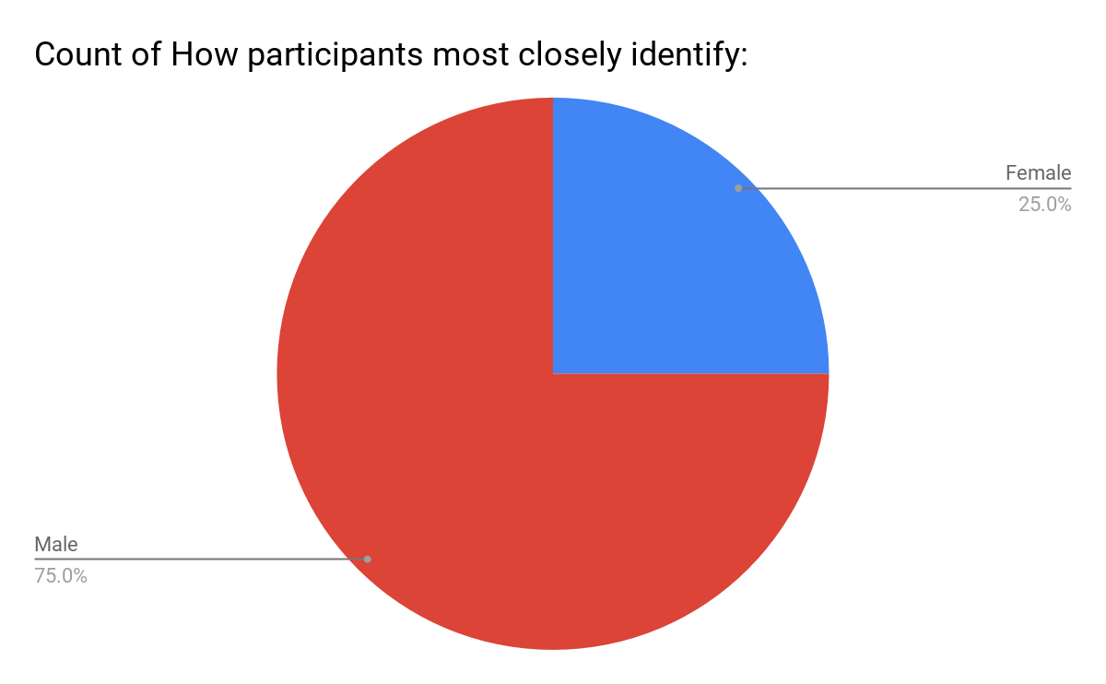
This question asks respondents to identify what gender do respondents most closely identify with. Respondents were given two choices: female or male. The results indicate that:
- 75% of respondents identify as male
- 25% of respondents identify as female

These results indicate that the majority of respondents identify as male.

Question 8: I most closely identify as (race/ethnicity):
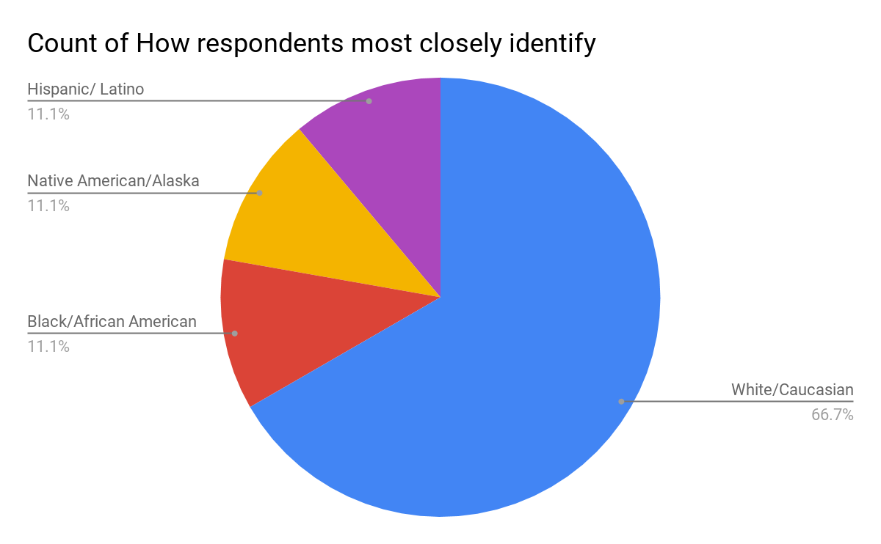
These results indicate that the number of male and female respondents are nearly equal.
This question asks respondents to identify their ethnicity. The results indicate that:
- 66.7% of respondents identify as White/Caucasian
- 12.5% of respondents identify as Black/African American
- 12.5% of respondents identify as Hispanic/Latino
- 12.5% of respondents identify as Native American/Alaska Native
- 0% of respondents identify as Asian/Asian American
- 0% of respondents identify as NAtive Hawaiian/Pacific Islander
- 0% of respondents identify as Two or More/Multiracial

These results indicate that the majority of respondents identify as White/Caucasian.

